Hi-Power Forensic 3-band Detection Light

-- OR-GSS600

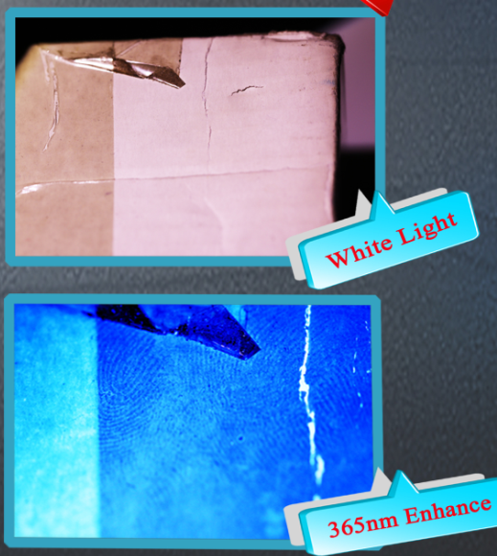
In crime scene investigation, fast and accurate detection of possible forensic traces is of vital important. Forensic Alternate Light Sources(ALS) have been used for detection of biological evidences, which can be detected due to their nature characteristic, such as light asorption (blood) or flurescence effect (semen, saliva, urine, vaginal fluids, sweat etc.). And ALS are invaluable for detecting substances at a crime scene such as bruising, hair, fibre, foot prints, fingerprints, stamps, Ninhydrine treated fingerprints, Super glue treated fingerprints, basic yellow 40, stamps, Cyanacrylate and general searching.
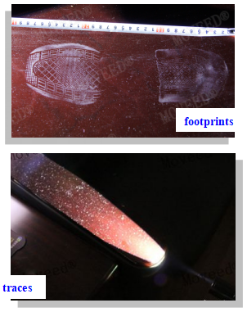
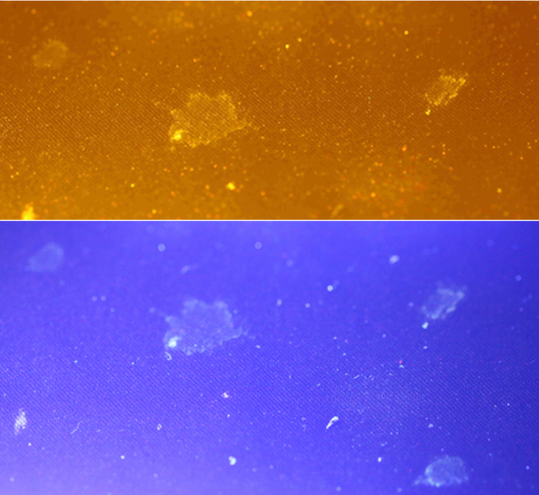

Biological evidence
Untreated old fingerprint
footprints

traces

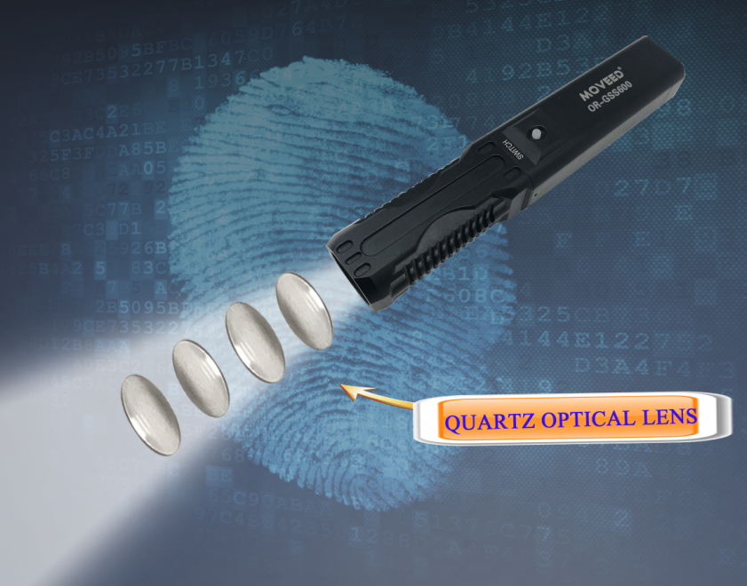
WAVELENGTHS(all-in-one):
white 6500k/10W
blue 450nm/10W
UV 365nm/10W

FEATURES :
- Designed specially for crime scene situations and equipped with long lived rechargeable Li-ion 18650 batteries, lightweight design with extreme portability
- Optical lens group design, Quartz Optical Lens designed for best UV light utility.
- Lighting design achieves both higher output power and more uniform circular spot, and “speckle free” beam
- 3-wavelengths design in one handheld unit and support practical use
- One button for 3-wavelengths switchable in sequence (“all-in-one” feature)
- It is comes with a tripod interface, through which the device can be fixed to a tripod for taking photographs
- Air-cooling system enables the light unit working in normal temperature.
- Low battery indicator，it turns red when the power less than 15%.

SPECIFICATION:
- Model No.: OR-GSS600
- Wavelengths: A. white 6500k/10W B. blue 450nm/10W C. UV 365nm/10W
- Battery Voltage: DC8.4V Battery capacity: 2000mAh
- Charging power: DC5V/2A
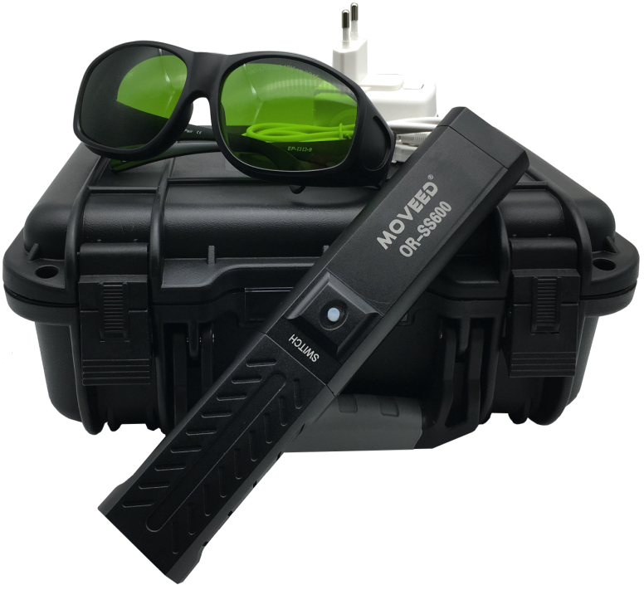
- Light spot diameter at 0.5 m: ≥35 cm
- Light spot diameter at 1 m: ≥68 cm
- Dimension: 212*40*32 mm
- Weight:0.4kg (battery included)

PPRODUCT DISPLAY:

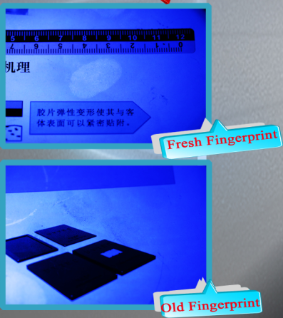
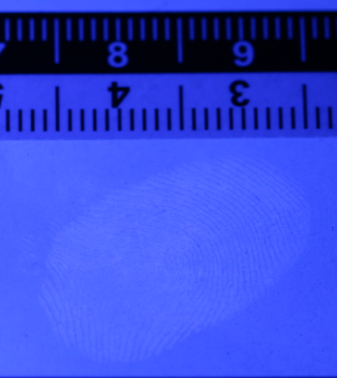
EFFECT PIC.:
Untreated fresh fingerprint

Untreated Fingerprints on glossy paper
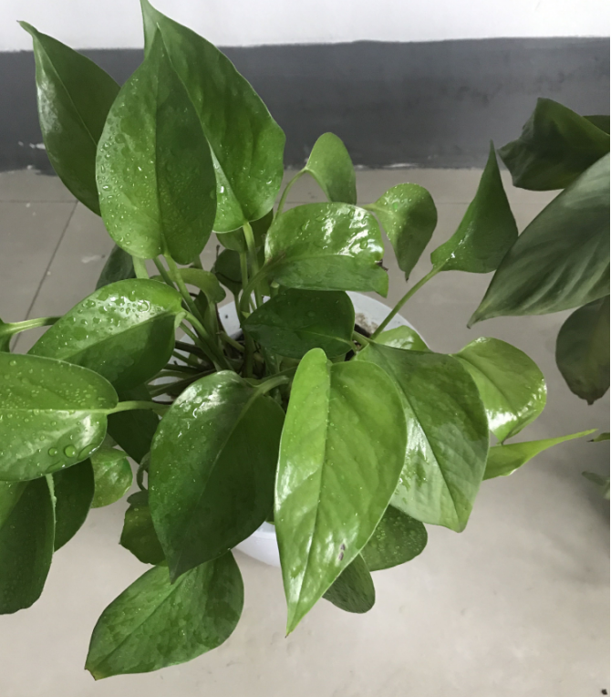
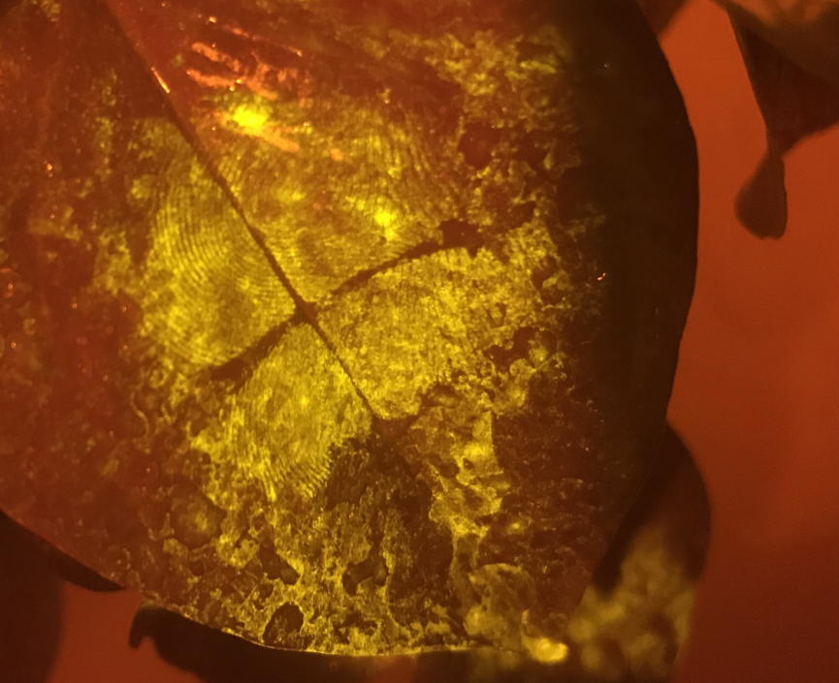

Treated Fingerprints on leaf
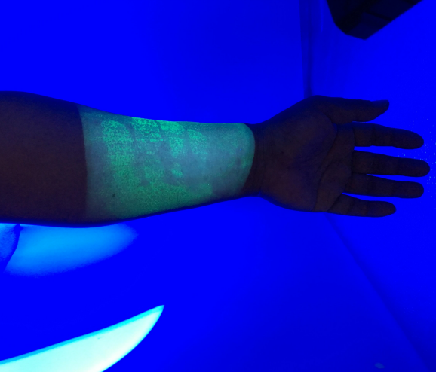
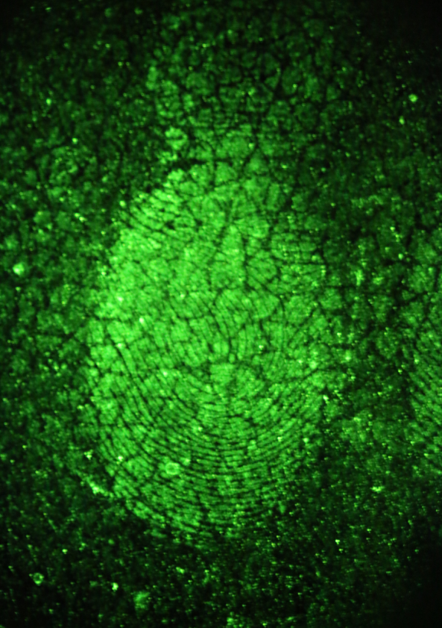
Treated Fingerprints on skin

